Survey Implementation

Document

Translation Protocol

Zone of Influence Surveys

Updated April 2024

This protocol is made possible by the support of the American People through the U.S. Agency for International Development under the terms of OASIS IDIQ No. GS00Q14OADU209, Task Order No. 7200AA21M00009. The contents of this protocol are the sole responsibility of ICF and do not necessarily reflect those of the U.S. Agency for International Development or the United States Government.

**Recommended Citation**

ICF. 2024. *Feed the Future Survey Implementation Document:* *Translation Protocol.* Reston, VA: ICF

**Feed the Future Contact Information**

[refs.ald@usaid.gov](mailto:refs.ald@usaid.gov)

**TABLE OF CONTENTS**

1. Introduction 1

2. Terms used in this protocol 1

3. Determining the translations needed 2

4. Translation approach: The TRAPD model 2

5. Translation process 4

Step 1. Finalize the source language documents. 4

Step 2. Identify and train the translation team for each target language. 4

Step 3. Translate the documents. 5

Step 4. Conduct a team review of the translation and adjudicate discrepancies, as necessary. 5

Step 5. Review, pretest, and revise translations during TOT, Interviewers’ training, and pretest activities, including during the cognitive testing, survey pretest, and pilot. 6

Step 6. Ensure that all revisions to translations are documented in the Translation Revision Log. 7

References 8

Appendix: Translation Revision Log template 9

# Introduction

Appropriate translation procedures are central to the quality of any survey questionnaire and, therefore, to the quality of collected data. Translations of survey documentation, including questionnaires and manuals used by field staff, must follow a specific protocol to avoid situations in which poor translation of survey documents results in the collection of invalid and unreliable data. 

This translation protocol describes the procedures that should be followed for optimal translation of survey documents for Feed the Future Zone of Influence (ZOI) Surveys. Before reading this protocol, refer to the survey scope of work and survey protocol to understand how translation fits into the overall survey implementation process and timeline and to understand key roles and responsibilities between the survey Contractor and local Survey Implementing Organization (SIO). If not working with an SIO, the Contractor is responsible for all aspects of the translation process.

# Terms used in this protocol

**Source language:** A language from which a document is to be translated into another language. Most often, the source language is the one in which the document is developed. For ZOI Surveys, the source language is standard American English, as spoken and written in the United States.

**Official language:** A language that has been officially designated for legal and governmental business in a country. When English is not an official language or the language in which trainings will be conducted, one of the country’s official languages will serve as one of the questionnaire target languages and the target language for field staff manuals.[1]

**Target language:** A language into which a document is to be translated. For ZOI Surveys, target languages comprise all languages into which the questionnaires will be translated. A target language may be an official language of a country. A target language can also be a local version of English that differs significantly from American English, such as Liberian English.

**One-stage translation process:** A translation process in which the source language document is used to produce all target language translations.

**Two-stage translation process:** A translation process in which the source language document is first translated into an intermediate target language—often an official language in the survey country. The intermediate target language document is then used to produce one or more additional target language translations.

**Translation team:** A group of individuals—two or more Translators and one Adjudicator—who collaborate to produce the target language translation. Each target language will have a separate translation team.

**Translator:** A member of the translation team who independently translates a document from one language into another.

**Adjudicator:** A member of the translation team who reviews the translations with the Translators and leads the process of resolving any discrepancies among translations. The Adjudicator decides which version of the translation will be included in the final document.

**Survey team:** The Contractor and local SIO staff who collaborate to implement the survey.

# Determining the translations needed

Feed the Future ZOI Survey questionnaires must be translated into relevant target languages. At a minimum, language groups that constitute the native language of 10 percent or more of the ZOI population must have a formally translated questionnaire. In countries in which the trainings will not be conducted in English, the I*nterviewer’s Manual, Anthropometry Manual* (if applicable), *Field Supervisor’s Manual, Quality Control and Support Team’s Manual,* and *In-Country Data Manager’s Manual* must also be translated into the language in which trainings will be conducted.

# Translation approach: The TRAPD model

After the target languages have been identified, translation of survey documents should be implemented using an approach based on the TRAPD Team Translation Model (Harkness, 2003). TRAPD is an acronym for five interrelated procedures required for optimal translation: Translation, Review, Adjudication, Pretesting, and Documentation. Feed the Future’s standard approach to translation for ZOI Surveys is a modified version of the TRAPD Team Translation Model (see **Figure 1**).

**Figure 1: ZOI Survey-Adapted TRAPD Team Translation Model**

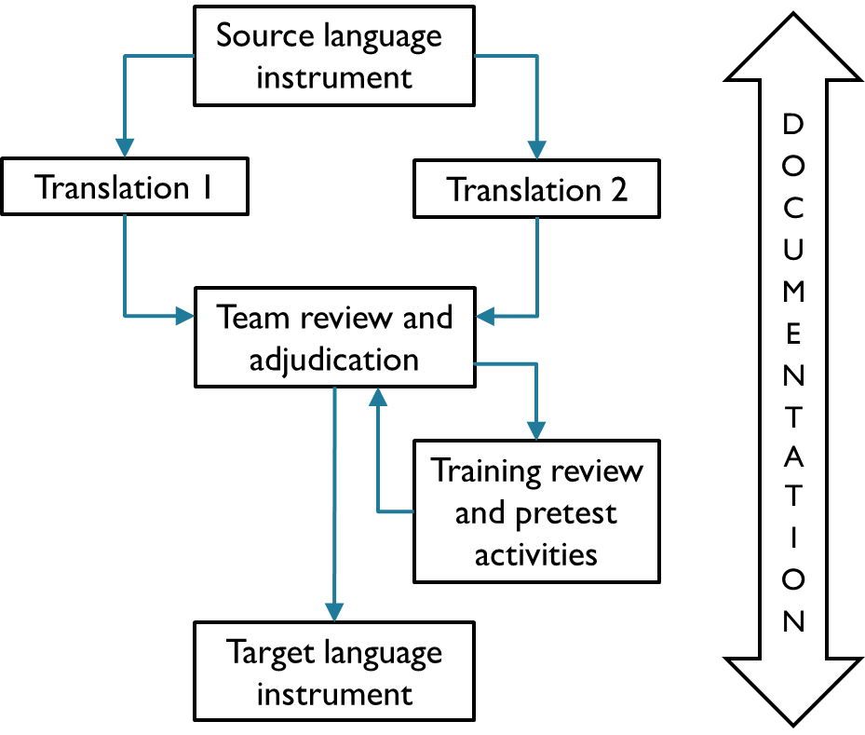

Adapted from: Mohler et al. (2016)

For most ZOI Surveys, a one-stage translation process can be used—that is, the source language document can be used to produce all target language translations. When implementing a one-stage translation process, the following steps will be implemented. These steps are discussed in greater detail in the subsequent section.

1. Finalize the source language documents.
2. Identify and train the translation team for each target language.
3. Translate the documents.
4. Conduct a team review of the translations and adjudicate discrepancies, as necessary.
5. Review, pretest, and revise translations during training and pretest activities, including during the training of trainers (TOT), cognitive testing (if applicable), survey pretest, and pilot.
6. Ensure that all revisions to translations are documented in the Translation Revision Log.

Steps 3 and 4 of the translation process, which can occur at the same time for multiple target languages, are expected to take approximately 3 weeks per target language.

For some ZOI Surveys, the source language document cannot be used to produce all target language translations because Translators needed to produce target language translations from the source language are not available. For these surveys, a two-stage translation process is required. First, the source language document must be translated into an intermediate target language—often an official language in the survey country—and reviewed. The intermediate target language translation will then be translated into additional target languages and reviewed. In short, for those countries in which a two‑stage translation process is required, Steps 1–4 will occur for the translation from the source language into the intermediate target language, and then Steps 2–4 will occur for the translation from the intermediate target language into each additional target language. This two-stage process doubles the amount of time required for translation and review and must be considered when developing the survey timeline.[2]

If translation of the *Interviewer’s Manual*, *Anthropometry Manual* (if applicable), *Field Supervisor’s Manual*, *Quality Control and Support Team’s Manual*, and *In-Country Data Manager’s Manual* into the intermediate target language is also required for training purposes, the process for translation of these documents will follow a modified version of Steps 1–4. In Step 2, only one translation needs to be produced for each manual, rather than two translations. In Step 4, the Adjudicator will review the translation for each manual and resolve any concerns directly with the Translator to produce final translations of manuals.

# Translation process

This section describes in greater detail the steps involved in the ZOI Survey translation process. Because most ZOI Surveys will follow a one-stage translation process, the section is written accordingly. See the previous section for accommodations needed to implement a two-stage translation process.

## Step 1. Finalize the source language documents.

Before beginning translation, the Contractor should finalize and freeze the source language documents to be translated. At this point, the Contractor should identify questionnaire items and sections of other survey documentation (e.g., the *Interviewer’s Manual*) for which translations exist from previous surveys (including previous ZOI Surveys), considering both those that were conducted in the same country as well as those conducted in countries with a shared language. The Contractor should then determine whether cultural or other contextual adaptation to existing translations is required or whether they can be used as is. It is important to clearly note those items for which translation is required. If using translations from previous ZOI Surveys conducted in the same country, the same question wording should be used for consistency, particularly when collecting data that will be compared over time.

## Step 2. Identify and train the translation team for each target language.

The local SIO will identify a translation team for each target language. A minimum of three team members (two Translators and one Adjudicator) per target language will be trained on Feed the Future’s ZOI Survey translation process, using this protocol as a key resource. The Translators will ideally be located in or originally from the country where the survey is to take place and have at least near-native fluency in the target language.

Translation team members should have a solid understanding of the survey objectives, procedures, and survey content, including terms and concepts that are used in the survey documents. The local SIO Survey Director should serve as the Adjudicator and be a fluent speaker of one or more target languages, including the intermediate target language if a two-stage translation process is required. Although it is best practice to identify an Adjudicator with fluency in each target language, this may not be logistically possible. However, assigning one Adjudicator to multiple translation teams provides an advantage, as their participation across translation teams can facilitate consistency in interpretation of questionnaire items during the team review and adjudication process. Furthermore, the Adjudicator can seek guidance from other team members when necessary.[3]

The Contractor Country Lead will be responsible for training the translation teams on the ZOI Survey translation process. Training will include a review of the survey documents to be translated, focusing on items for which there are no existing translations. This review will include an opportunity to discuss any words or phrases in the source language documents that are ambiguous or confusing.

## Step 3. Translate the documents.

For each target language, after the translation team has been trained, each Translator will separately translate the survey documents into the target language, resulting in two independent translations. Having more than one Translator separately translate the documents encourages consideration of alternative translations and can reduce idiosyncratic or unintended regional preferences.

Each Translator will translate each document in its entirety, except for questions or sections flagged by the Contractor Country Lead as needing only a review for accuracy or minor adaptation rather than a new translation (e.g., translations that already exist from a previous survey). If an inaccuracy is noted in an existing translation, Translators should revise and record any necessary adjudication notes in the Translation Revision Log. Please refer to Step 6 and the **Appendix** for the Translation Revision Log template and instructions on how to complete it. The Log will provide a record of all translation changes made throughout survey preparation activities, including during the review of existing translations (Step 3), the team translation review and adjudication process (Step 4), and training and pretesting activities (Step 5). The Contractor will retain a copy of the Log as part of the survey documentation.

Translators should avoid word-for-word translations but instead focus on translating the meaning of the question, response option, or instruction. However, it is important that the translation retain any formatting (e.g., capitalization, location in questionnaire structure) from the source language version because this formatting provides important instructions to the Interviewer.

## Step 4. Conduct a team review of the translation and adjudicate discrepancies, as necessary.

The Translators will share their translations with each other and with the Adjudicator, and a meeting will be organized among the translation team and the Contractor Country Lead to review and compare the drafts. In the review of each target language translation, the translation team should perform the following activities:

* Compare the target language versions to the source language version.
* Compare the two target language versions to identify inconsistencies or other comprehension issues and discuss solutions as a team. If there is disagreement in how to proceed, the Adjudicator holds the final decision-making authority. If the Adjudicator does not have strong skills in the target language, they should consult with experts in the target language for guidance as necessary.
* Ensure that no substantive information has been lost in translation.

Translation teams will work to achieve consensus on issues and accurately document those decisions in a new version of the target language document. Revisions and associated decision-making rationale used during this step will be recorded by translation team members in Columns 1–6 of the Translation Revision Log. Please refer to Step 6 and the **Appendix** for the Log template and instructions on how to complete it.

When translating survey questionnaires, after the team review and adjudication process has been completed, the Contractor Data Processing Manager and Census and Survey Processing System Developer will use the translated questionnaires to customize the Census and Survey Processing System computer-assisted personal interviewing applications in preparation for the TOT.

## Step 5. Review, pretest, and revise translations during TOT, Interviewers’ training, and pretest activities, including during the cognitive testing, survey pretest, and pilot.

After the translation team review and adjudication process is completed, the Contractor and local SIO will review and test the translations during the cognitive testing, TOT, survey pretest, Interviewer’s training, and pilot. Each activity is described in this section. The protocols and report templates referred to in this step are all available in the Feed the Future ZOI Survey Methods Toolkits.[4]

***Cognitive testing.*** The United States Agency for International Development, the Contractor, and the local SIO will collaborate to determine whether cognitive testing to assess question comprehension and respondents’ ability to answer will be required and will conduct the testing following the guidance provided in the *Cognitive Testing Protocol*. Although the primary purpose of cognitive testing is to assess the questions themselves, it is also an opportunity to assess the quality of the translations of the selected questions. The Contractor Country Lead will make any necessary revisions to translations as a result of cognitive testing, ensure that they are captured in all relevant survey materials (e.g., questionnaires, data collection applications, *Interviewer’s Manual*, training slides), and document them and the associated decision-making rationale using the *Cognitive Testing Report Template.* In addition, the Country Lead will ensure that all revisions to translations and associated decision-making rationale are captured in the Translation Revision Log (see Step 6).

***TOT.*** During the TOT, participants will review the translations with a specific focus on the questionnaires. The Contractor Country Lead will make any necessary revisions to translations that result from the TOT review, ensure that they are captured in all relevant survey materials (e.g., questionnaires, data collection applications, *Interviewer’s Manual*, training slides), and document them and associated decision-making rationale using the *TOT and Survey Pretest Report Template.* In addition, the Country Lead will ensure that all revisions to translations and associated decision-making rationale are captured in the Translation Revision Log (see Step 6).

***Survey pretest.*** The local SIO will conduct a survey pretest at the conclusion of the TOT. The survey pretest will be conducted according to the *Survey Pretest Protocol* to test data collection procedures and the tablet-based computer-assisted personal interviewing system under fieldwork conditions. It is also an opportunity for senior field staff to further assess the quality of the translations, noting any issues as they arise. The Contractor Country Lead will make any necessary revisions to translations as a result of the survey pretest, ensure that they are captured in all relevant survey materials (e.g., questionnaires, data collection applications, *Interviewer’s Manual*, training slides), and document them and associated decision-making rationale using the *TOT and Survey Pretest Report Template*. In addition, the Country Lead will ensure that all revisions to translations and associated decision-making rationale are captured in the Translation Revision Log (see Step 6).

***Interviewers’ training.*** During the Interviewers’ training, participants will review the questionnaire translations as they receive instruction on the questionnaire content. Although the translations should be near-final at this stage, translation errors may still be identified. The Contractor Country Lead will make any necessary revisions to translations that are identified during the training, ensure that they are captured in all relevant survey implementation materials (e.g., questionnaires, data collection applications, *Interviewer’s Manual*, training slides), and document them and associated decision-making rationale using the *Main Field Staff Training and Pilot Report Template.* In addition, the Country Lead will ensure that all revisions to translations and associated decision-making rationale are captured in the Translation Revision Log (see Step 6).

***Pilot.*** The local SIO will conduct a pilot at the conclusion of the main field staff training. The pilot will be conducted according to the *Pilot Protocol* and serve as a survey dress rehearsal during which the survey team practices implementing all survey procedures under fieldwork conditions. It is also a final opportunity for field staff to assess the translations and resolve any issues before data collection begins. The Contractor Country Lead will ensure that any necessary revisions to translations as a result of the pilot are captured in all relevant survey materials (e.g., questionnaires, data collection applications, *Interviewer’s Manual*, training slides), and document them and associated decision-making rationale using the *Main Field Staff Training and Pilot Report Template*. In addition, the Country Lead will ensure that all revisions to translations and associated decision-making rationale are captured in the Translation Revision Log (see Step 6).

## Step 6. Ensure that all revisions to translations are documented in the Translation Revision Log.

Throughout the translation process, all revisions to translations will be documented in the Translation Revision Log. After all training and pretest activities have been completed, the Contractor Country Lead will ensure that the information in the Log is complete and comprehensive—including information for all target languages as documented throughout the translation process. See the **Appendix** for the Log template and instructions on how to complete it. Note that the Log is not a working document; it is only for documentation—to ensure that all translation revisions made throughout survey preparation activities are recorded in one place. The Log should be submitted to the United States Agency for International Development and retained by the Contractor as part of the survey documentation.

# References

Harkness, J.A. (2003). Questionnaire translation. In J.A. Harkness, F. van de Vijver, & P. Ph. Mohler (Eds.), *Cross-cultural survey methods* (pp. 35-56). Hoboken, NJ: John Wiley & Sons.

Mohler, P., et al. (2016). Translation: Overview. *Guidelines for best practice in cross-cultural surveys.* Ann Arbor, MI: Survey Research Center, Institute for Social Research, University of Michigan. Retrieved from <http://ccsg.isr.umich.edu/>chapters/translation/overview.

# Appendix: Translation Revision Log template

When reviewing and pretesting translations, please use the Translation Revision Log template in this Appendix to document all translation revisions that are made during the translation team review and adjudication process and during the training and pretest activities. Because the Log is large, it can be maintained in Excel, with a separate tab for each target language. An Excel-based Log template is available in the Feed the Future ZOI Survey Methods Toolkits.[5]

***Instructions for the translation team’s review of existing translations, if applicable (Step 3)***

Columns 1–5 in the Log should be used to document suggested revisions to existing translations identified during the review of existing translations (Step 3). Enter the following in the specified columns:

* Column 1: Item number in a questionnaire or section number in other documents being

translated

* Column 2: Version of the item in the source document
* Column 3: Translation used in the previous survey
* Column 4: Translation suggested by the Translator
* Column 5: Rationale for the translation revision documented in Column 4

***Instructions for the translation team review and adjudication process (Step 4)***

Columns 1, 2, and 6–9 in the Log should be used to document translation revisions agreed to in Step 4 during the translation team’s review. Enter the following in the specified columns:

* Column 1: Item number in a questionnaire or section number in other documents being

translated

* Column 2: Version of the item in the source document
* Column 6: Version of the item as translated by Translator 1
* Column 7: Version of the item as translated by Translator 2
* Column 8: Rationale for the translation revision documented in Column 6, including for items

added to the Log in Step 3

* Column 9: Version of the item that will be used as a result of the translation team review and

adjudication process, including for items added to the Log in Step 3

***Instructions for the TOT, Interviewers’ training, and pretest activities (Step 5)***

Columns 1, 2, and 10–12 in the Log should be used to document translation revisions agreed on in Step 5 during training and pretest activities. Enter the following in the specified columns:

* Column 1: Item number in the questionnaire or section number in other documentation being

translated (if not already entered in the Log in Step 4; if already logged, skip to Column 7)

* Column 2: Version of the item as stated in the source document (if not already entered in the

Log in Step 3)

* Column 10: Stage at which the translation was updated: cognitive testing, TOT, survey

pretest, Interviewer’s training, or pilot

* Column 11: Rationale for the translation change documented in Column 12
* Column 12: Version of the item that will be used after the training, pretest, or pilot activity

**Translation Revision Log Template**

|  |  |  |  |  |  |  |  |  |  |  |  |
| --- | --- | --- | --- | --- | --- | --- | --- | --- | --- | --- | --- |
| **Target language:** | | | | | | | | | | | |
| **Step 3** | | | | |  | | | | | | |
| **Step 4** | |  | | | **Step 4** | | | |  | | |
| **Step 5** | |  | | | | | | | **Step 5** | | |
| **(1)** | **(2)** | **(3)** | **(4)** | **(5)** | **(6)** | **(7)** | **(8)** | **(9)** | **(10)** | **(11)** | **(12)** |
| **Question/ section #** | **Source version** | **Previous translation** | **New translation** | **Comments/ rationale new translation** | **Translation 1** | **Translation 2** | **Adjudication comments/ rationale** | **Post-adjudication version** | **Stage of revision\*** | **Comments/ rationale for revision** | **Revised version** |
|  |  |  |  |  |  |  |  |  |  |  |  |
|  |  |  |  |  |  |  |  |  |  |  |  |
|  |  |  |  |  |  |  |  |  |  |  |  |
|  |  |  |  |  |  |  |  |  |  |  |  |
|  |  |  |  |  |  |  |  |  |  |  |  |
|  |  |  |  |  |  |  |  |  |  |  |  |
|  |  |  |  |  |  |  |  |  |  |  |  |

*Stage of revision: Cognitive testing, TOT review, Survey pretest, Interviewers’ training, or Pilot

Notes:

Columns 10–12 are used only if a change was made after the team review and adjudication process (i.e., during training or pretest activities).

If changes to a question are made at multiple stages during the trainings and pretest activities, use a separate row to record each additional change.

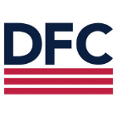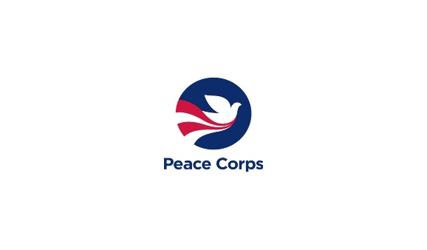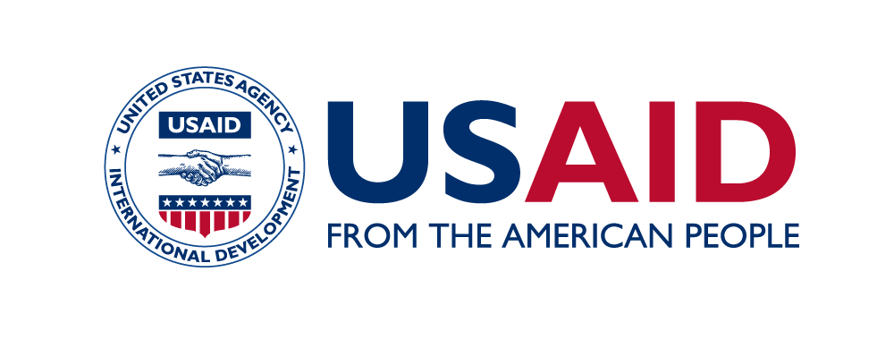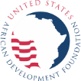

www.feedthefuture.org

www.feedthefuture.gov

1. Not all countries have an official language, and some countries have more than one official language. In such countries, when English is not the language in which trainings will be conducted, the Contractor and the United States Agency for International Development will agree to a language that will be used for trainings and into which the field staff manuals will be translated.
2. If a two-stage process is required, the first stage (translation of the source language document into an intermediate target language) may be led by the Contractor or the local SIO, and the second step (translation of the intermediate target language document into the additional target languages) would then be led by the local SIO.
3. If the SIO Survey Director is not fluent in all target languages, the Contractor and the United States Agency for International Development will agree to a translation team composition appropriate to the country context.
4. <https://agrilinks.org/post/feed-future-zoi-survey-methods-toolkit-endlineround-1-2024>
5. <https://agrilinks.org/post/feed-future-zoi-survey-methods-toolkit-endlineround-1-2024>